Sigman Veterinary Clinic
10257 Highway 142 North
Covington, Georgia 30014
770-787-1581
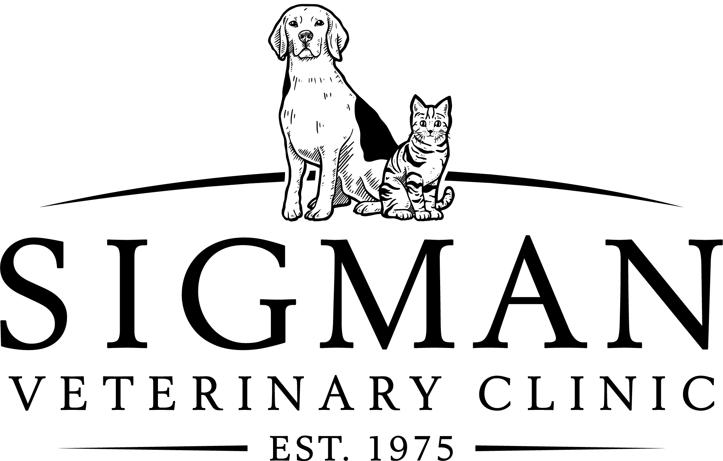

Dental Consent Form
Client Name:______________________________ Account#_________________ Date:______________

Pet Name:____________________________________Breed/Color:_______________________________
Please provide contact information at which you can be reached during the day of your pets scheduled procedure

Primary Contact Name:______________________________________ Phone: ______________________

Secondary Contact Name:____________________________________ Phone:______________________

Your pet has been scheduled for a dental procedure to treat/prevent periodontal disease. General anesthesia is required to perform these procedures. After your pet is placed under anesthesia, a Registered Veterinary Technician (RVT) will clean your pet’s teeth under veterinarian supervision with ultrasonic and hand scaling instruments the same way a dental hygienist cleans your teeth. We will examine your pet’s teeth and gum tissue using a dental probe and your pet will have full mouth dental x-rays taken. This will determine if further treatment is indicated such as extractions. Your pet’s teeth will then be polished and rinsed. Extractions (pulling) of diseased/damaged teeth may be necessary due to advanced periodontal disease. Please feel free to discuss this with the veterinarian and an estimate can be given to you at your request. Please indicate your choice below with your initials.

I understand that the veterinarian will not be able to fully examine my pet’s teeth and oral cavity prior to the induction of anesthesia. The presence of dental disease such as diseased and/or fractured teeth, and/or oral masses may be detected and require surgical intervention including dental extractions and/or gum surgery. I understand that the fees for such procedures are in addition to those quoted to me for a routine dental cleaning; this may include antibiotics, antibiotic gels, and/or additional pain medications.

__________ YES, perform any necessary procedures (such as extractions) at the discretion of the veterinarian. I understand that I am responsible for any additional fees as described above.

__________ NO, DO NOT perform extractions/ additional procedures beyond a basic dental cleaning. I understand that additional procedures can be scheduled at a later date and that anesthesia will have to be repeated.

__________ I prefer to be referred to a veterinary dental specialist if additional procedures are recommended. Teeth will not be extracted and only a dental cleaning will be performed.

I understand that the removal of some teeth may result in unavoidable consequences, such as jaw fractures, and/or an inability of the pet to keep its tongue in the mouth. I do not hold Sigman Veterinary Clinic and its staff liable. I understand that I am responsible for additional fees for extractions and/or additional dental procedures. I hereby authorize the veterinarians to examine, prescribe for, and/or treat the above described pet. I assume responsibility for all charges incurred in the care for and treatment of this animal. I certify that I have read and signed the accompanying Anesthesia/Surgery Consent form.

_____________________________________________________ ___________________________
Signature of owner or agent Date

